24INMCAL391 - RDBMS LAB
24INMCAL393 - USER INTERFACE AND DESIGN LAB
24INMCAT307 - SOFTWARE ENGINEERING

Microproject Report Submitted By

LIDA ELSA JACOB

AJC24MCA-I037

In Partial fulfillment for the Award of the Degree Of

INTEGRATED MASTER OF COMPUTER APPLICATIONS
(MCA FIVE YEAR)

AMAL JYOTHI COLLEGE OF ENGINEERING AUTONOMOUS, KANJIRAPPALLY

[Approved by AICTE, Accredited by NAAC.
Koovappally, Kanjirappally, Kottayam, Kerala – 686518]

2026-2027

DEPARTMENT OF COMPUTER APPLICATIONS

AMAL JYOTHI COLLEGE OF ENGINEERING AUTONOMOUS, KANJIRAPPALLY



CERTIFICATE
This is to certify that the Microproject report, "24INMCAL391 - RDBMS Lab", "24INMCAL393 - User Interface and Design Lab" and "24INMCAT307 - Software Engineering" is the bonafide work of LIDA ELSA JACOB (AJC24MCA-I037) in partial fulfilment of the requirements for the award of the Degree of Master of Computer Applications under Amal Jyothi College of Engineering, Autonomous Kanjirappally during the year 2026-27.

Ms. Navyamol K T Dr. Bijimol T K

Lab In - Charge Head of the Department

2026-2027

Microproject Submission Report

Student Details
- Name: LIDA ELSA JACOB
- Roll Number: 35
- Department: COMPUTER APPLICATIONS
- Semester: S5
- College Name: AMAL JYOTHI COLLEGE OF ENGINEERING

Project Overview
1. Customer Section (Public Access)

Track Package: Enter a tracking number (e.g., TRK-98241) to view the current parcel status.

Delivery Partner Details: Displays the delivery partner’s name and mobile number for direct contact.

Live Checkpoints: Shows shipment progress (e.g., “Sorted at Delhi Hub” → “Out for Delivery”).

Customer Route Instructions: Displays customer-provided landmarks and directions (e.g., “Enter via Gate 3 near Metro Pillar”).

File a Complaint: Customers can submit complaints about delayed or damaged parcels.

View Admin Reply: Customers can view the administrator’s response to their complaints.

2. Delivery Partner Section (Name and Password Login)

Secure Login: Delivery partners log in using their name and password.

Delivery Details: Displays the delivery address, customer name, and contact number.

Availability Status: A checkbox indicates whether the delivery partner is busy delivering or free to accept new orders. Changes notify the admin.

Google Maps Navigation: Opens GPS directions using the customer’s route instructions.

Update Shipment Status: Delivery partners can update shipment statuses to “Picked Up” or “Delivered.”

3. Admin Section (Password: admin123)

Delivery Partner Monitoring: Displays all delivery partners and their availability status.

Customer Complaints: Shows customer complaints and the associated delivery partner.

Reply to Customers: Allows the admin to respond to complaints, with replies visible to customers.

Route Tracking: Displays active shipments on a map for monitoring deliveries.

4. Technical Implementation (Simple Explanation)

React and React Router: Provide a responsive interface and navigation between pages without full page reloads.

Node.js and Express.js: Handle backend operations and communication between the frontend and database.

RDBMS and SQL JOIN Queries: Connect the couriers, customers, and delivery_partners tables to retrieve related shipment information.

Google Maps Integration: Provides one-click GPS navigation using customer addresses and route instructions.

Technologies Used
1. Customer Section (Public Access)

• Track Package: Enter a tracking number (e.g., TRK-98241) to view the current parcel status.

• Delivery Partner Details: Displays the delivery partner’s name and mobile number for direct contact.

• Live Checkpoints: Shows shipment progress (e.g., “Sorted at Delhi Hub” → “Out for Delivery”).

• Customer Route Instructions: Displays customer-provided landmarks and directions (e.g., “Enter via Gate 3 near Metro Pillar”).

• File a Complaint: Customers can submit complaints about delayed or damaged parcels.

• View Admin Reply: Customers can view the administrator’s response to their complaints.

2. Delivery Partner Section (Name and Password Login)

• Secure Login: Delivery partners log in using their name and password.

• Delivery Details: Displays the delivery address, customer name, and contact number.

• Availability Status: A checkbox indicates whether the delivery partner is busy delivering or free to accept new orders. Changes notify the admin.

• Google Maps Navigation: Opens GPS directions using the customer’s route instructions.

• Update Shipment Status: Delivery partners can update shipment statuses to “Picked Up” or “Delivered.”

3. Admin Section (Password: admin123)

• Delivery Partner Monitoring: Displays all delivery partners and their availability status.

• Customer Complaints: Shows customer complaints and the associated delivery partner.

• Reply to Customers: Allows the admin to respond to complaints, with replies visible to customers.

• Route Tracking: Displays active shipments on a map for monitoring deliveries.

4. Technical Implementation (Simple Explanation)

• React and React Router: Provide a responsive interface and navigation between pages without full page reloads.

• Node.js and Express.js: Handle backend operations and communication between the frontend and database.

• RDBMS and SQL JOIN Queries: Connect the couriers, customers, and delivery_partners tables to retrieve related shipment information.

• Google Maps Integration: Provides one-click GPS navigation using customer addresses and route instructions.

Concepts Implemented
Subject | Concept Used
Database Management Systems (DBMS / RDBMS) | - Relational Schema Design & Normalization:  - Structured normalized schema across 6 independent relational entities:  couriers,  customers,  delivery_partners,  problems,  checkpoints, and  activity_logs.  - Integrity Constraints & Foreign Keys:  - Enabled relational constraints (PRAGMA foreign_keys = ON;).  - Enforced referential integrity via FOREIGN KEY (customer_id) REFERENCES customers(id) and ON DELETE CASCADE.  - Multi-Table SQL JOIN Queries:  - INNER JOIN & LEFT JOIN: Joins courier shipments with recipient customer records and assigned delivery partner credentials.  - 3-Way Relational JOIN: Connects customer problem reports with shipment details, customer identity, and the assigned delivery rider.  - Aggregations & Grouping (GROUP BY & COUNT):  - Dynamically computes fleet workload and availability (who is delivering vs. who is free) using COUNT(CASE WHEN c.status != 'Delivered' THEN 1 END) grouped by rider ID.  - ACID Transactions & Data Persistence:  - Persistent storage using the native SQLite engine (node:sqlite) with parameterized statements to prevent SQL Injection.
Modern Web Application Development & Frontend Engineering | - Single Page Application (SPA) Architecture:  - Built using React 19 with client-side state handling and component lifecycle management.  - Client-Side Declarative Routing (React Router v7):  - Implemented  BrowserRouter,  Routes,  Route, and dynamic navigation links without full page reloads.  - Distinct route isolation for / (Customer Portal), /delivery (Rider Portal), and /admin (Operations Console).  - Component-Based Hierarchy & Props:  - Modular design separating page views (  CustomerPortal,  DeliveryPortal,  AdminPortal) from shared modals (  GoogleMapModal,  SqlInspectorModal).  - React State Management & Controlled Inputs:  - Utilized useState for dynamic forms, checkbox toggles, and live textareas, with useEffect for real-time polling and lifecycle data fetching.  - Virtual DOM & List Reconciliation:  - List rendering utilizing unique key props on dynamic checkpoint timelines and shipment cards.  - Design System & Responsive UI/UX:  - Custom Vanilla CSS design tokens with glassmorphism, responsive CSS grid, flexbox, and micro-animations.
[Subject 3] | Backend & RESTful Web API Engineering  - RESTful API Architecture:  - Developed using Node.js and Express.js, following standard HTTP verbs (GET for retrieval, POST for mutation).  - Middleware Pipeline:  - Request parsing via express.json().  - Cross-Origin Resource Sharing handled via cors().  - Global error-handling middleware preventing server crashes and returning standardized JSON error payloads.  - Reverse Proxy & Network Communication:  - Configured Vite development server proxy (/api -> http://localhost:5001) to eliminate CORS issues and emulate production routing.  - Real-Time Audit Logging & Event Tracking:  - Centralized event logger recording rider availability shifts (Delivering vs. Free), customer complaints, and admin replies.
Information Security & Role-Based Access Control (RBAC) | - Multi-Tier Authorization Model:  - Tier 1 (Public / Unrestricted): Customer tracking portal accessible without credentials.  - Tier 2 (Rider Authentication): Protected by paired identity verification (Rider Name + Password).  - Tier 3 (Super Admin Authentication): Secured via administrator master password (admin123).  - Session Persistence & State Isolation:  - Storing authenticated states in browser localStorage with automated logout capabilities.  - Input Sanitization & Injection Defense:  - Using parameterized SQL statements (db.prepare('... VALUES (?, ?)')) to guard against SQL injection vulnerabilities.
Information Security & Role-Based Access Control (RBAC) | Multi-Tier Authorization Model:  - Tier 1 (Public / Unrestricted): Customer tracking portal accessible without credentials.  - Tier 2 (Rider Authentication): Protected by paired identity verification (Rider Name + Password).  - Tier 3 (Super Admin Authentication): Secured via administrator master password (admin123).  - Session Persistence & State Isolation:  - Storing authenticated states in browser localStorage with automated logout capabilities.  - Input Sanitization & Injection Defense:  - Using parameterized SQL statements (db.prepare('... VALUES (?, ?)')) to guard against SQL injection vulnerabilities.

Screenshots of Code & Output
- Screenshot 1: Code Structure (insert image here)
- Screenshot 2: Output Sample (insert image here)

Real-Time Applications
1. E-Commerce Last-Mile Delivery (e.g., Amazon, Flipkart, Blue Dart, FedEx)
- Last-Mile Coordination: Connects fulfillment warehouses with delivery riders and doorstep customers.
- Customer Transparency: Customers know exactly who is arriving, their vehicle number, and their personal phone number for direct coordination.
- Reduction in Failed Deliveries (RTO): Customers provide specific gate, landmark, or route instructions (e.g., "Enter via Gate 3 near Metro Pillar"), preventing failed delivery attempts.

2. Hyperlocal Quick-Commerce & Food Delivery (e.g., Blinkit, Swiggy, Zomato, Zepto)
- Fleet Availability Management (Delivering vs. Free):
  - Operations admins can see in real-time which riders are free (idle) versus actively on a delivery route.
  - Allows dispatchers to assign incoming urgent orders to the nearest available rider.
- Turn-by-Turn GPS Navigation:
  - Riders launch Google Maps directly from the app, avoiding complex residential layouts and narrow alleys.

3. Emergency Medical & Pharmaceutical Logistics
- Critical Supply Chain Tracking:
  - Delivery of time-sensitive pathology samples, blood bags, vaccines, and emergency medicines to hospitals and diagnostic clinics.
- Live Accountability:
  - The admin console monitors checkpoints and ensures critical medical packages are moving without unauthorized delays.
- Urgent Problem Filing:
  - If a hospital customer reports a delay, the Operations Admin can immediately contact the assigned rider and prioritize delivery.

4. B2B Corporate, Banking & Legal Document Courier
- High-Security Parcel Handling:
  - Tracking confidential legal contracts, bank cards (credit/debit cards), and chequebooks.
- Full Audit Trail:
  - Checkpoint milestones record every scan (Processed, Dispatched, Out for Delivery, Delivered) with timestamps, rider names, and timestamps stored in the database.
- Direct Verification:
  - Recipients can verify the legitimate delivery agent by checking their name and personal number directly on the tracking portal.

5. Smart City Municipal & Postal Services (e.g., India Post, USPS, Royal Mail)
- Digital Grievance Redressal:
  - Replaces slow customer support calls with an integrated "File a Problem" and "Admin Reply" console where citizens get direct, trackable resolutions to delivery issues.
- Optimal Fleet Utilization:
  - Cities can distribute delivery workloads evenly among regional delivery personnel based on real-time "Free" vs "Delivering" statuses.

6. High-Value Electronics & Fragile Goods Transport
- Zero Route Confusion:
  - Fragile items (laptops, home decor, glassware) require precise route navigation to prevent unnecessary transit wear and rough roads.
- Real-Time Milestone Logging:
  - Riders update package checkpoints at every transit leg, ensuring insurance and warranty compliance.

Key Accomplishments of the Project
- Role-Based Access Control (3 Distinct Portals):
  - Customer Portal (Public): Democratizes parcel tracking with zero barriers, offering real-time visibility into current checkpoint milestones, assigned driver identity, and their personal contact number.
  - Delivery Rider Portal (Name & Password Authenticated): Equips delivery personnel with precise recipient details, phone numbers, and destination addresses.
  - Operations Admin Portal (Password Protected): Empowers logistics managers with fleet-wide monitoring, ticket resolution tools, and workload distribution.
- RDBMS Integrity & Multi-Table SQL JOINs:
  - Designed a normalized relational database enforcing foreign keys and referential integrity across 6 core entities (couriers, customers, delivery_partners, problems, checkpoints, activity_logs).
  - Replaced ad-hoc data queries with optimized INNER JOIN and LEFT JOIN operations to dynamically assemble customer, parcel, and driver data in single-query operations.
- Zero Route Confusion with Google Maps Integration:
  - Eliminated lost riders and delayed shipments by highlighting customer-specified landmarks and route advice.
  - Provided a direct, one-click bridge to Google Maps GPS Navigation, opening turn-by-turn driving directions with pre-filled coordinates.
- Dynamic Fleet Availability Management:
  - Implemented a real-time checkbox toggle (Delivering vs. Free) that instantly updates the backend database and alerts the Admin dashboard, ensuring idle riders are promptly reassigned to pending parcels.
- Closed-Loop Customer Grievance Redressal:
Bridged the communication gap between customers and dispatchers with an interactive Problem Filing Form and Admin Reply Console, allowing customer issues (e.g., gate confusion, urgent deadlines) to be answered and resolved in real time

Future Scope & Potential Enhancements
- IoT GPS Telematics: Integrating physical GPS hardware sensors/OBD-II devices on delivery vehicles for live vehicle coordinate streaming.
- AI Route Optimization: Introducing machine learning algorithms to automatically sequence multi-stop delivery routes based on live traffic data.
- Digital Proof of Delivery (e-POD): Adding recipient digital signatures and photo capture upon doorstep delivery.
- Automated SMS & WhatsApp Alerts: Integrating SMS/WhatsApp webhooks (e.g., Twilio API) to send automated dispatch and delivery notifications.

Conclusion
The SwiftRoute Courier Tracking & Logistics Management System successfully delivers an end-to-end, full-stack solution addressing the modern challenges of last-mile parcel delivery, driver allocation, and customer grievance resolution.
By integrating React 19, React Router v7, Node.js Express, and an SQLite Relational Database (RDBMS) with multi-table SQL JOIN Queries, the application provides a transparent, robust, and highly responsive platform connecting customers, delivery riders, and operations administrators.

Output
Customer Tracking
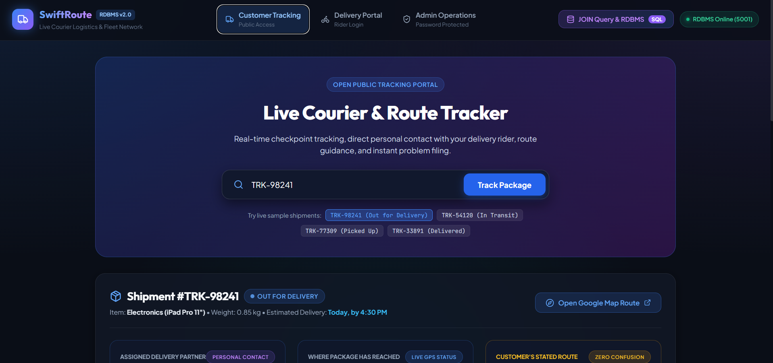

Delivery Portal
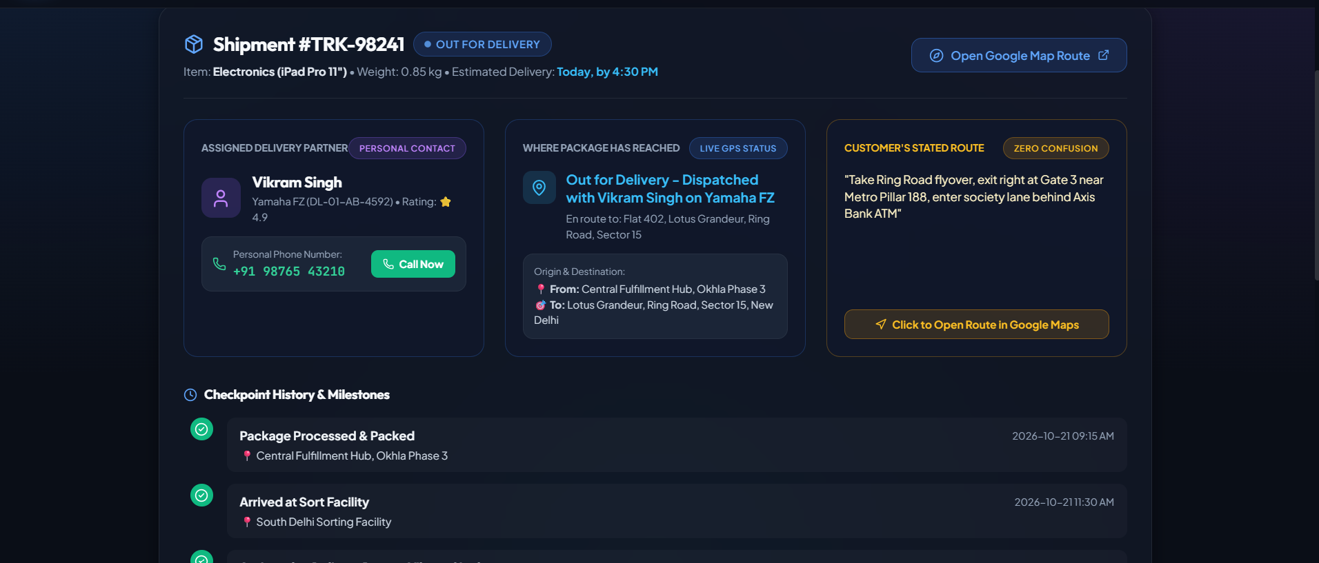
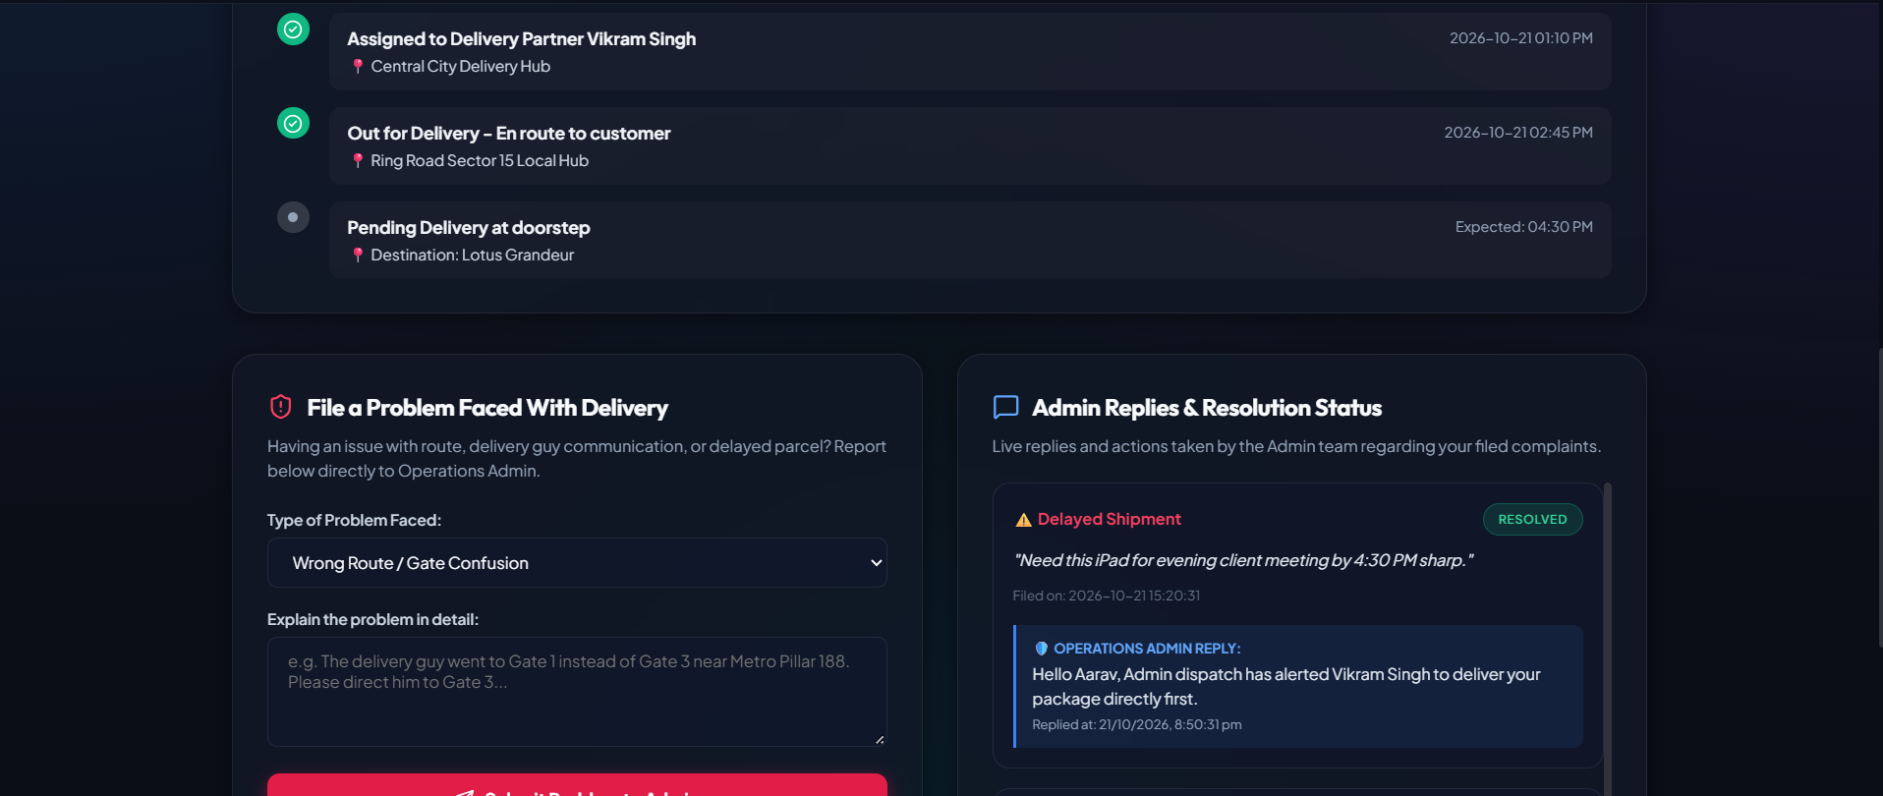
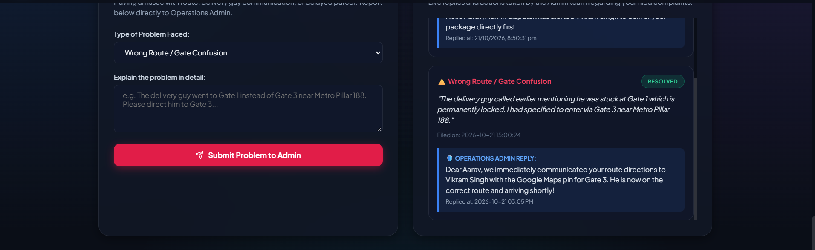
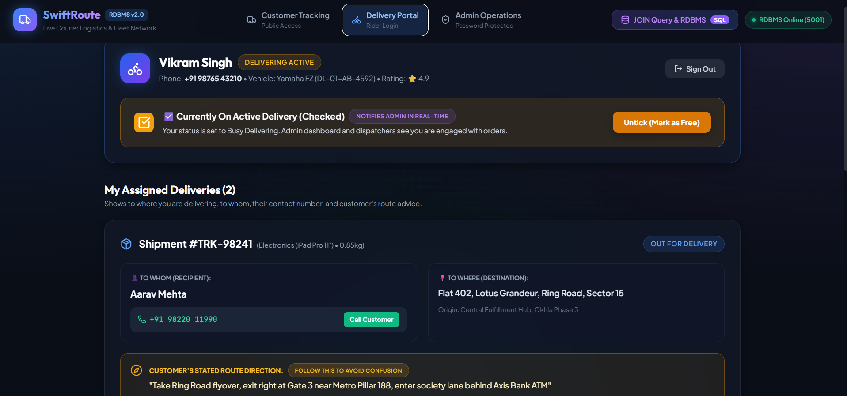

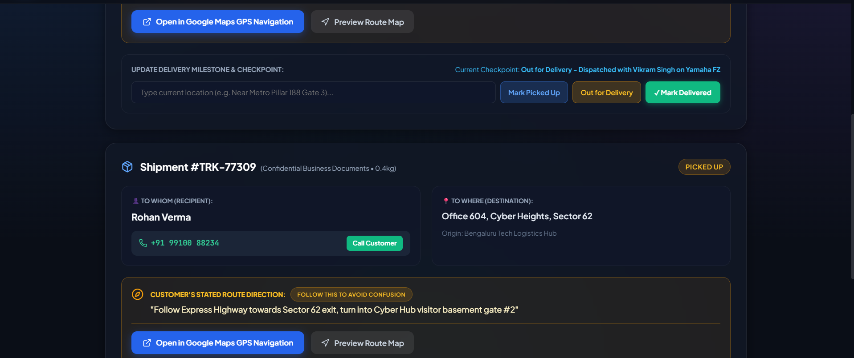
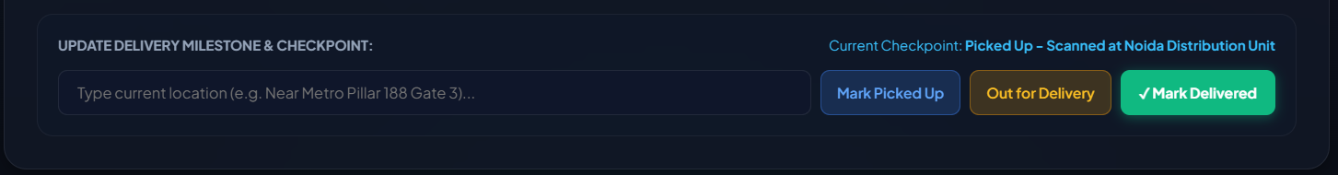

Admin Operations

